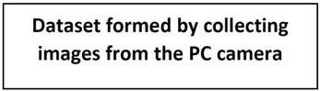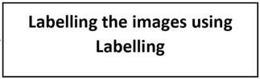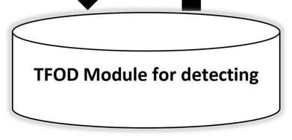

Project Design Phase –I

Solution Architecture

|  |  |
| --- | --- |
| Date | 17 OCTOBER 2022 |
| Team ID | PNT2022TMID40614 |
| Project Name | Real-Time Communication System Powered by AI for Specially Abled |
| Maximum Marks | 4 Marks |